# Sprint 4 - Sai Roopesh and Srihari Madhavan

As Instructed, we populated our MariaDB tables with data as follows:

1. ‘food_description’ table:

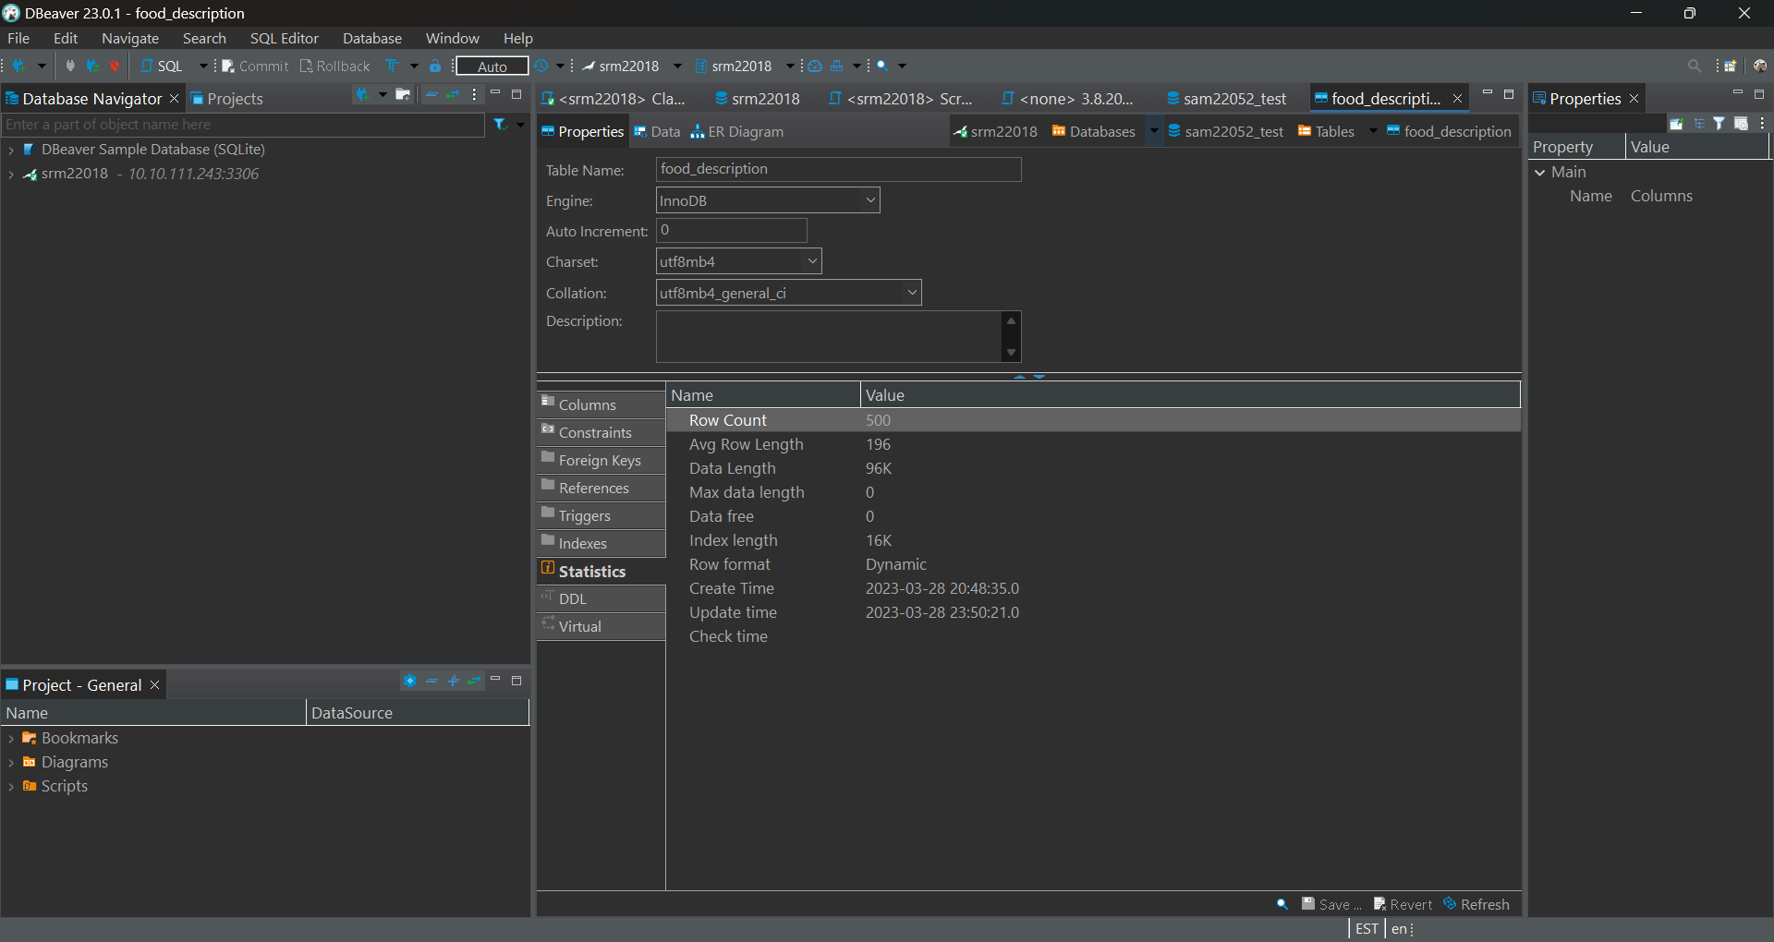

1. ‘food_group’ table:

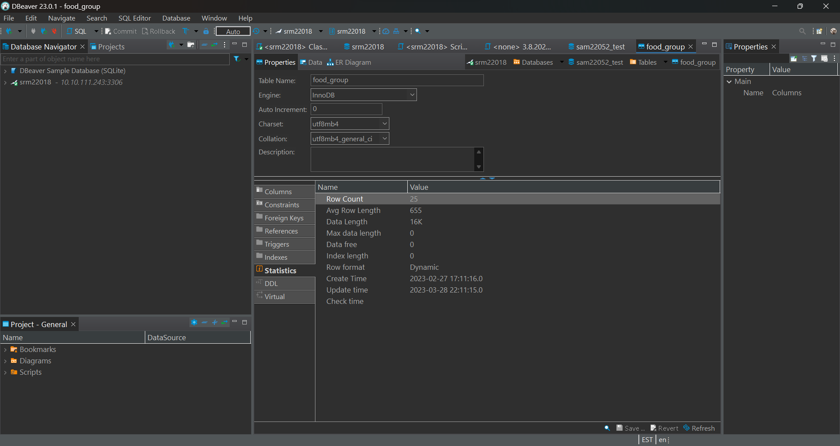

1. ‘common_name’ table:

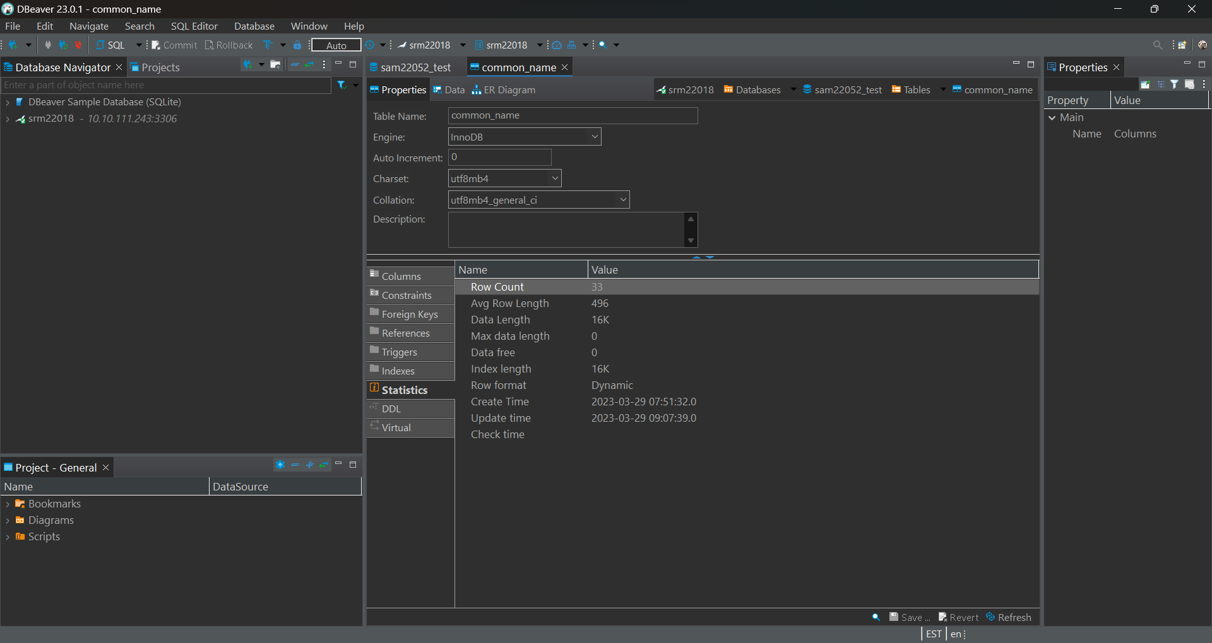

1. ‘manufacturing_name’ table:

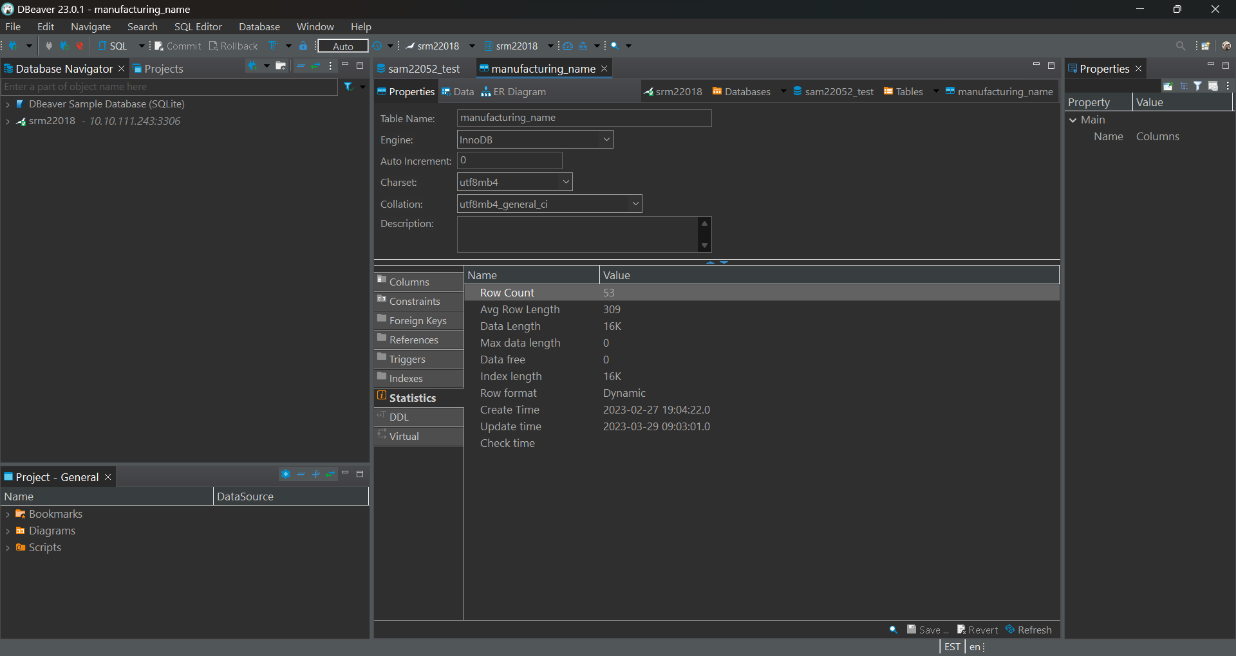

1. ‘scientific_name’ table:

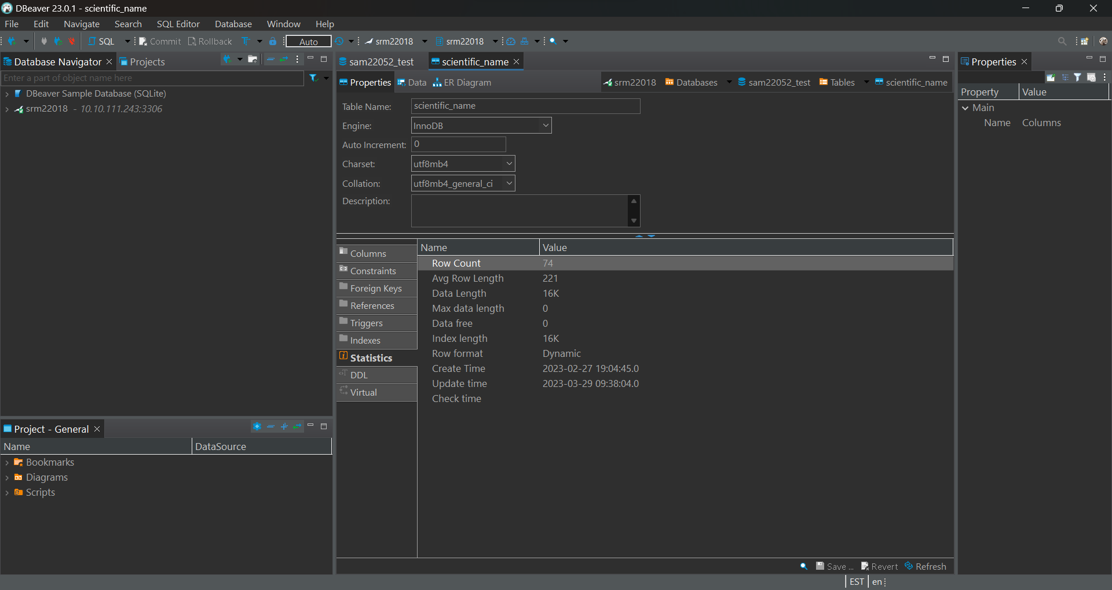

1. ‘diet_food_combination’ table:

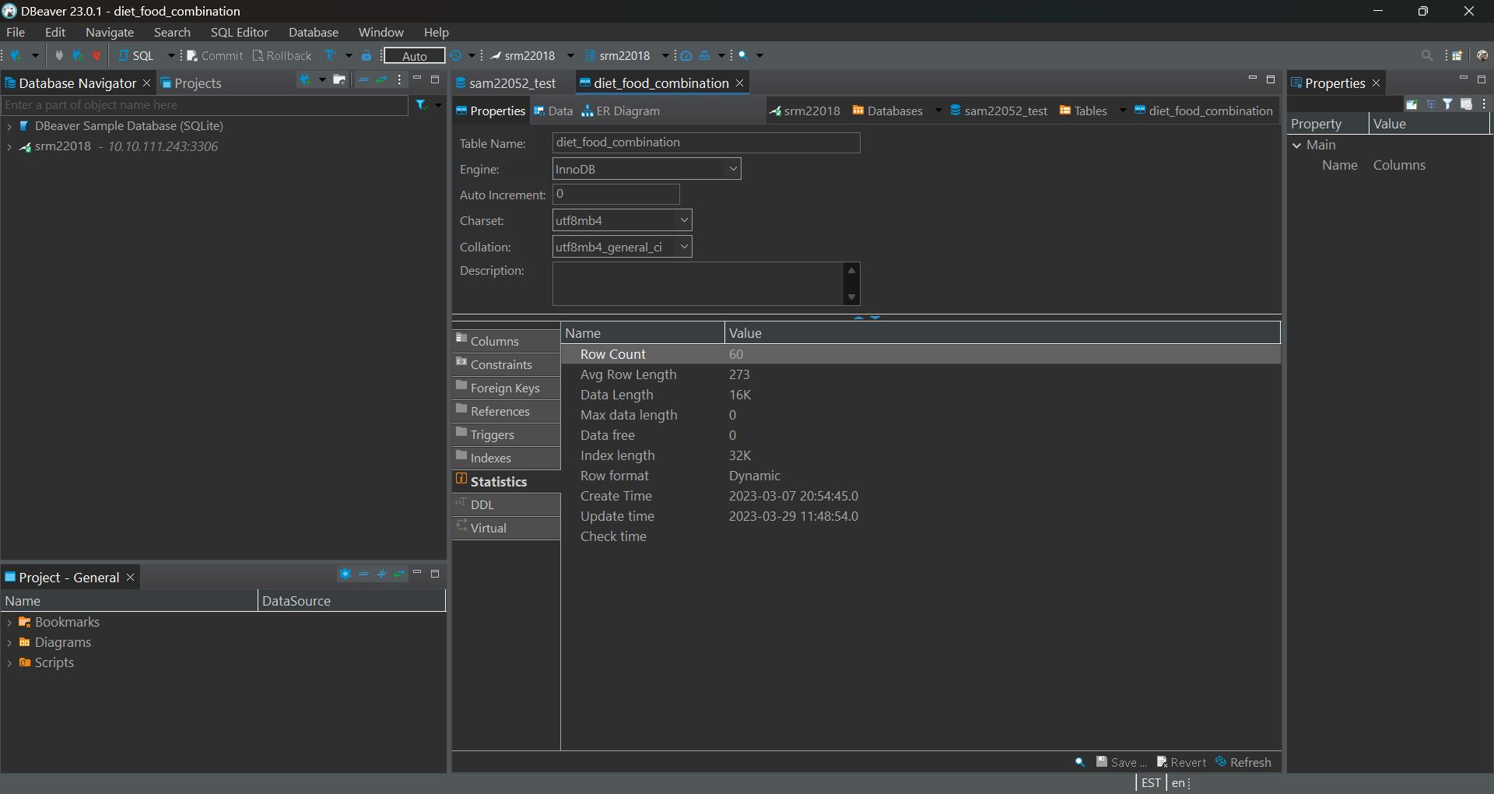

1. ‘diet_and_food_preferences’ table:

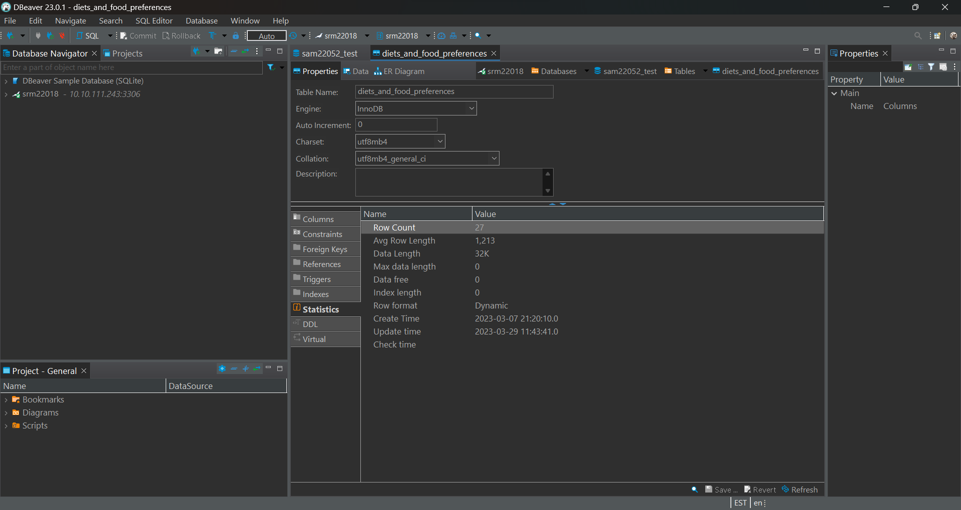

1. ‘prominent_deficiencies_by_country’ table:

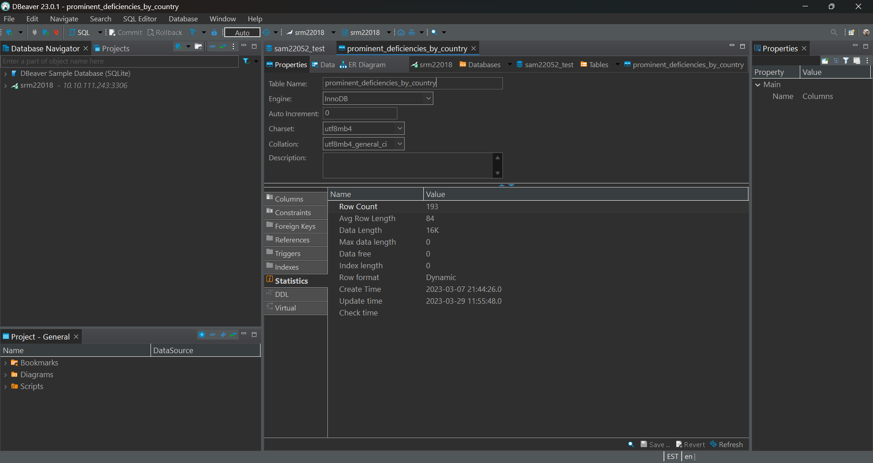

1. ‘country_deficiency_relationship’ table:

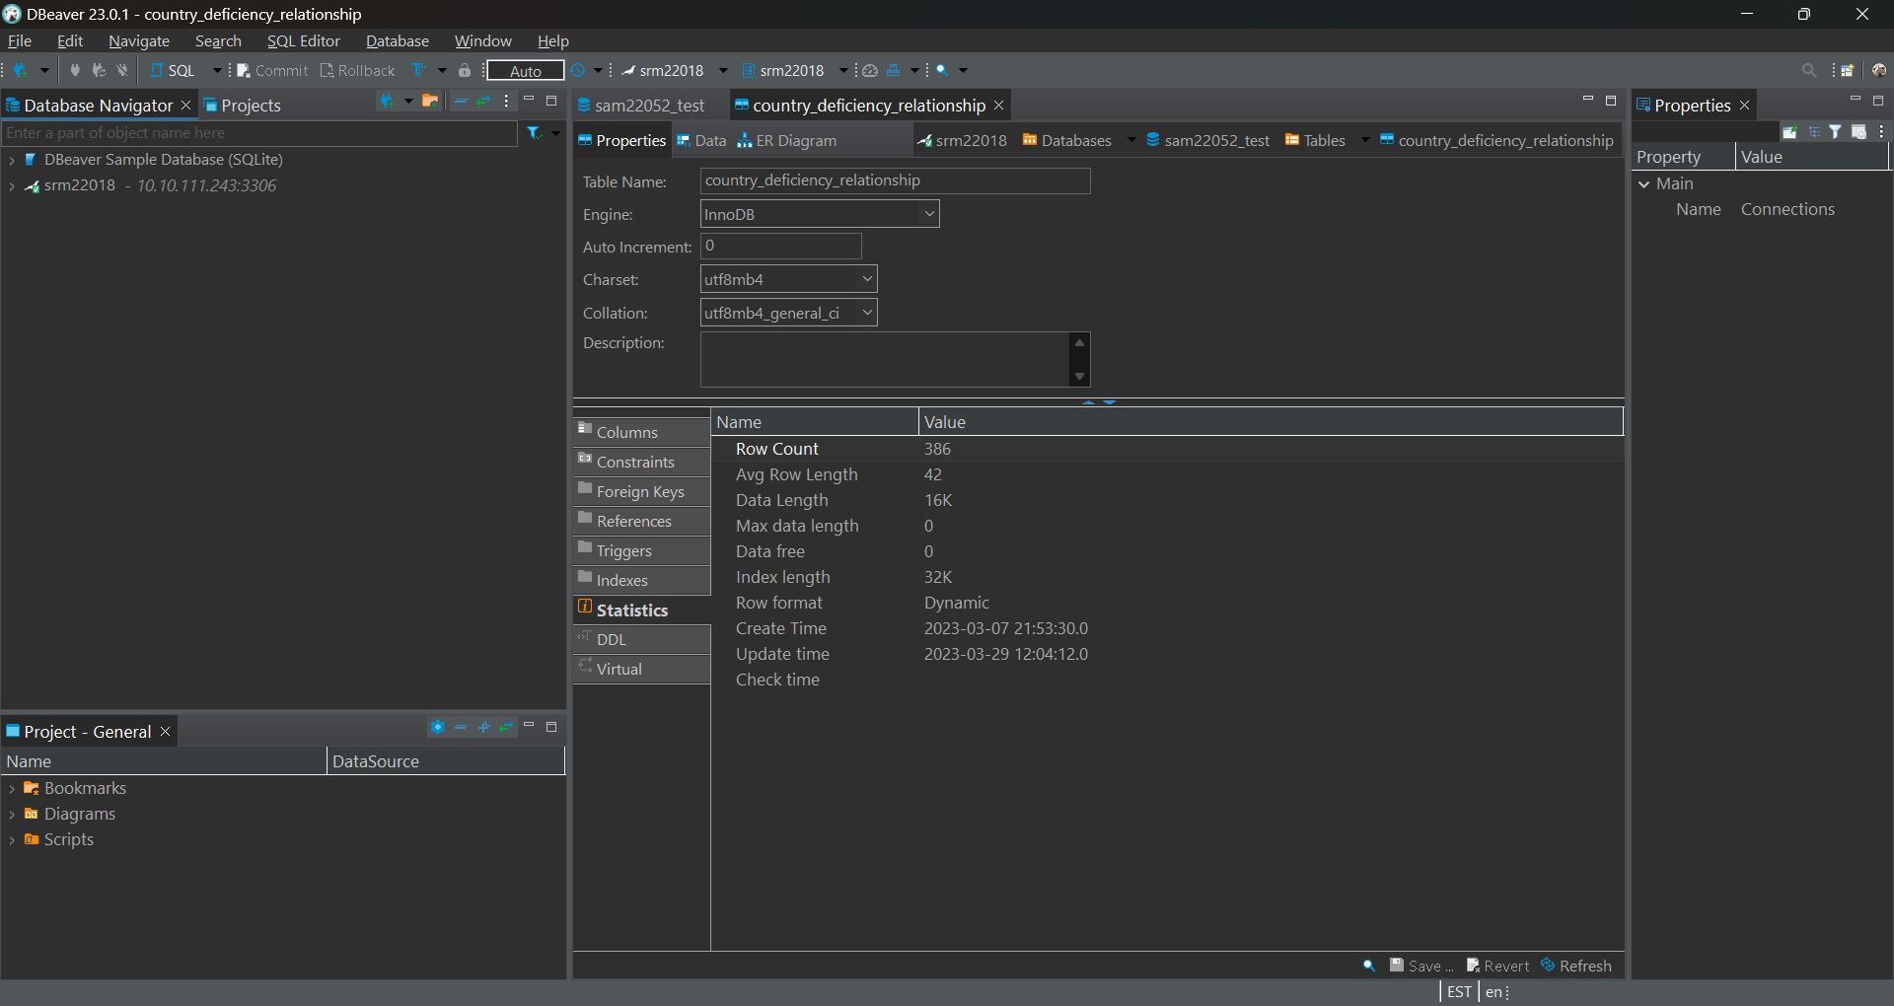

1. ‘nutrient_list’ table

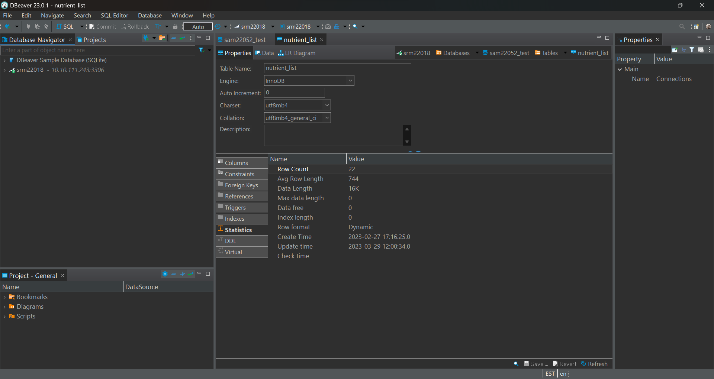

1. ‘nutrients_contained’ table

